**Course: Advance Bio Informatics**

**Module Title: Structure of HMM**

**Module No: 103**

**HMM Structure**

N - number of states Q = {q1; q2; : : : ;qT} - set of states

M - the number of symbols (observables)

O = {o1; o2; : : : ;oT} - set of symbols

A - the state transition probability matrix

aij = P(qt+1 = j|qt = i)

B- observation probability distribution

bj(k) = P(ot = k|qt = j)

i ≤ k ≤ M

π - the initial state distribution

Full HMM is thus specified as a triplet:

λ = (A,B,π)

**Example of HMM**

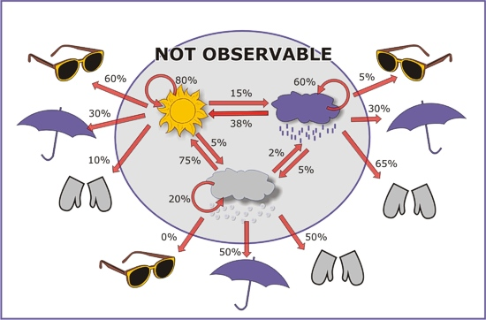

**Problems in HMM**

**Evaluation:**

Probability of occurrence of a particular observation sequence, O = {o1,…,ok}, given the model

P(O|λ)

Complicated – hidden states

Useful in sequence classification

**Decoding:**

Optimal state sequence to produce given observations,

O = {o1,…,ok}, given model

Optimality criterion. It is useful in recognition problems.

**Learning:**

Determine optimum model, given a training set of observations.

Find λ, such that P(O|λ) is maximal.